

Nama : Arya Ghiffari

NIM : 210511004

Kelas : D

Praktikum 1

1. Buatlah Class yang mengimplementasikan Prosedural, beri nama: celcius_pro.py
2. Buatlah Class yang mengimplementasikan Object Oriented Programming, beri nama: celcius_oop.py
3. Script
4. Celcius_pro.py

# Nama  : Arya Ghiffari

# Nim   : 210511004

# Kelas : D

class Celcius:

    @staticmethod

    def to_fahrenheit(celsius):

        return (celsius * 9/5) + 32

    @staticmethod

    def to_kelvin(celsius):

        return celsius + 273.15

    @staticmethod

    def to_reamur(celsius):

        return celsius * 4/5

mycelcius = 70

myfahrenheit = Celcius.to_fahrenheit(mycelcius)

print("konversi ",mycelcius, "derajat celcius adalah ",myfahrenheit, "derajat fahrenheit")

mykelvin = Celcius.to_kelvin(mycelcius)

mycelcius = 60

print ("konversi ",mycelcius, "derajat celcius adalah ",mykelvin, "derajat Kelvin")

mycelcius = 90

myreamur = Celcius.to_kelvin(mycelcius)

print ("konversi ",mycelcius, "derajat celcius adalah ",myreamur, "derajat Reamur")

1. Celcius_oop.py

# Nama  : Arya Ghiffari

# Nim   : 210511004

# Kelas : D

class Celcius:

    def __init__(self, celcius):

        self.c = celcius

    def fahrenheit(self):

        return (self.c * 9/5) + 32

    def kelvin(self):

        return self.c + 273.15

    def reamur(self):

        return self.c * 4/5

celciusA = Celcius(75)

print(f"Fahrenheit: {celciusA.fahrenheit()}")

celciusA = Celcius(60)

print(f"Kelvin: {celciusA.kelvin()}")

celciusA = Celcius(90)

print(f"Reamur: {celciusA.reamur()}")

1. Output
2. Celcius_pro.py

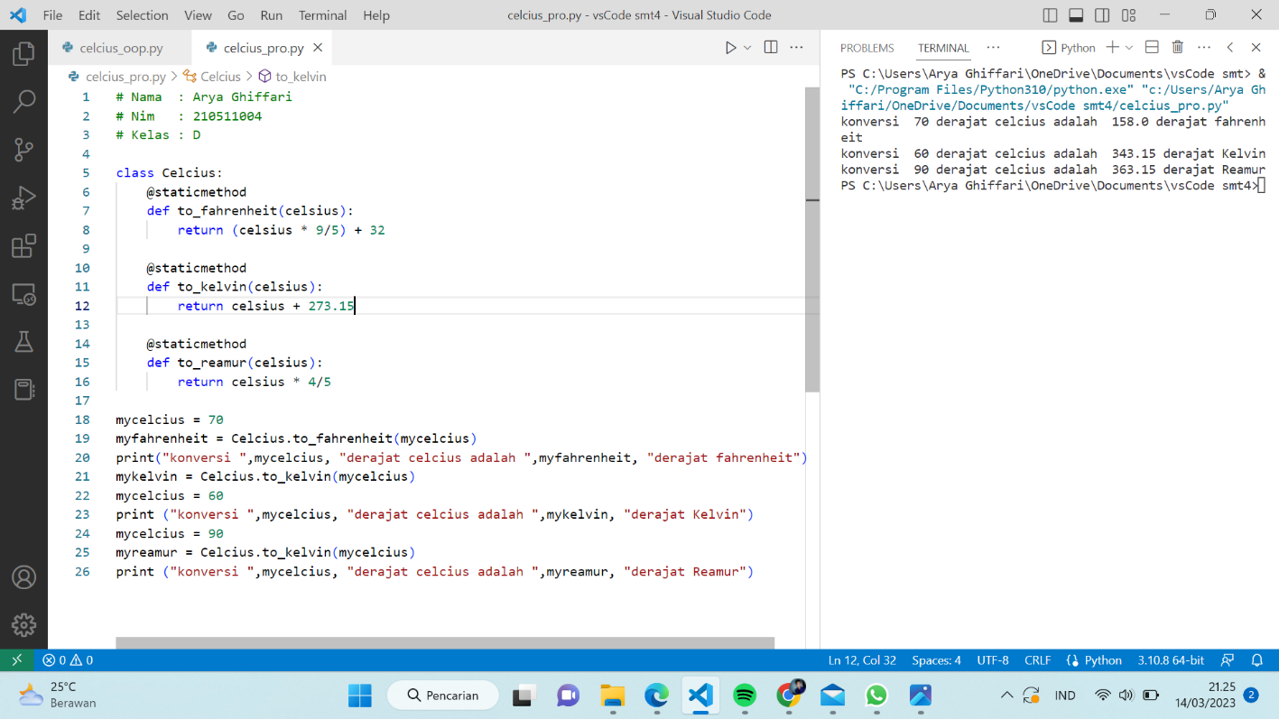

1. Celcius_oop.py

